# Address Book

## Purpose

The purpose of this is to establish the major requirements necessary to develop address book in offline mode which can assist the storage, retrieval , updation , deletion of contact details in a user friendly manner

Project Start with this User Interface:

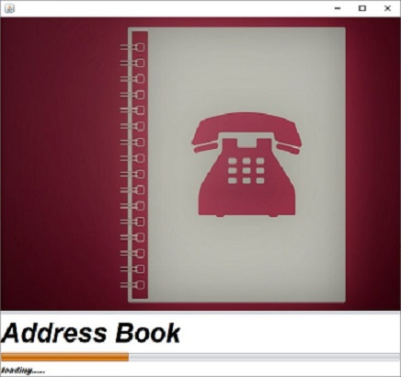

Then another screen popup Appears just for Attractive UI

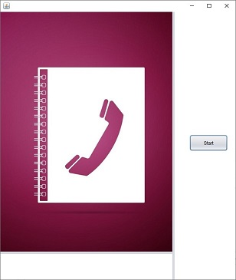

User Details are Being Fetched From Database

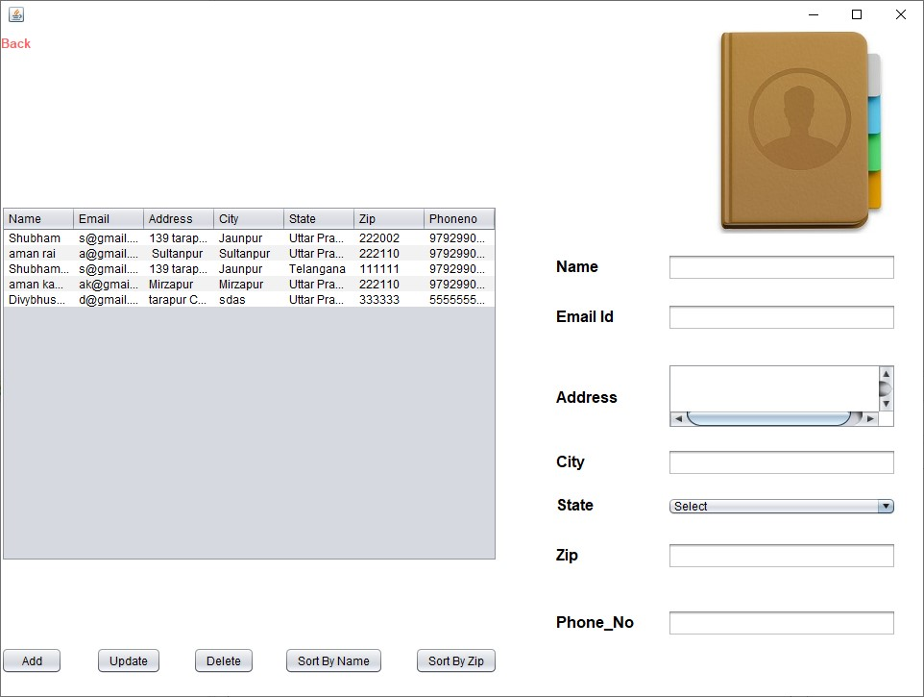

Crud Operations are as Follows

(1)Add

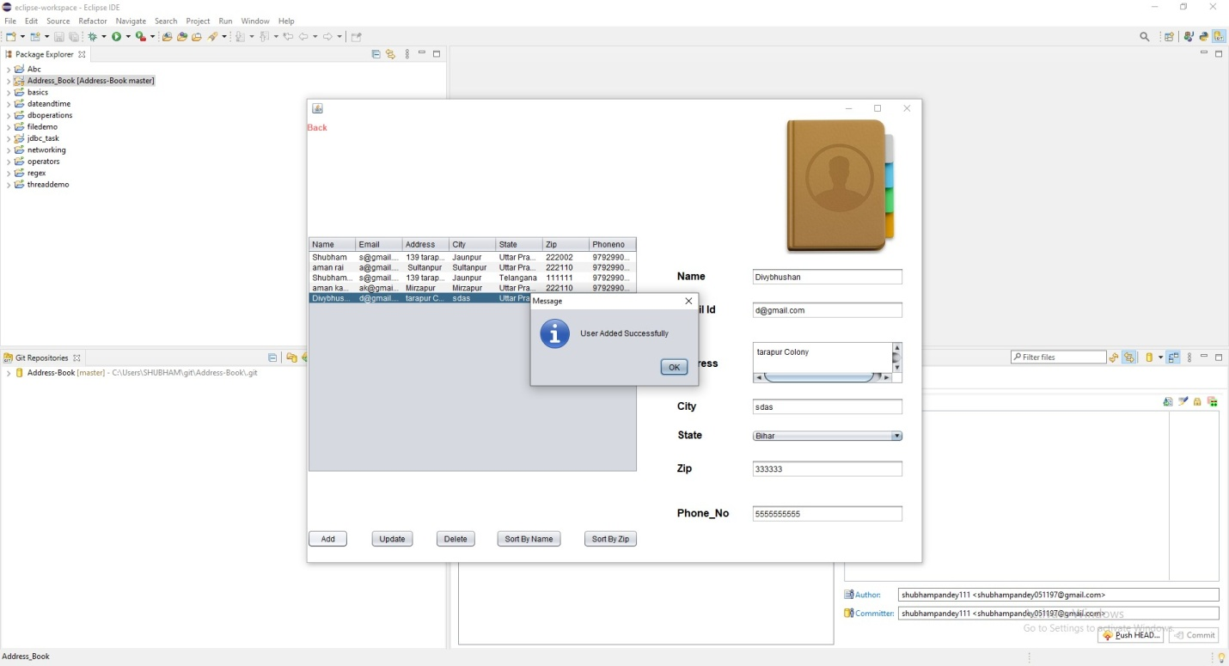

(2)Delete

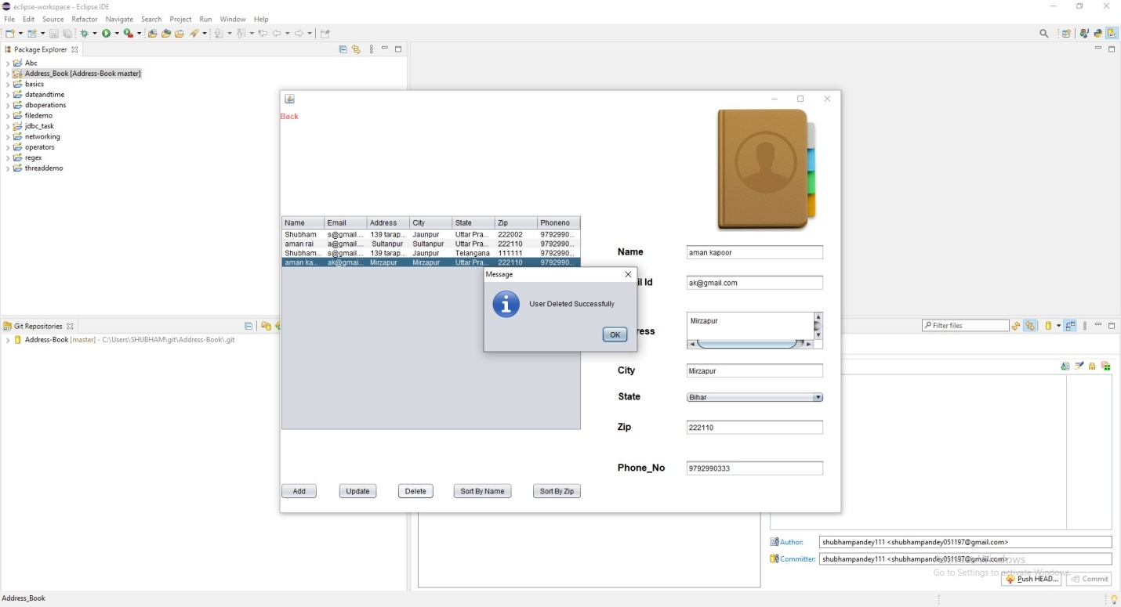

(3)Update

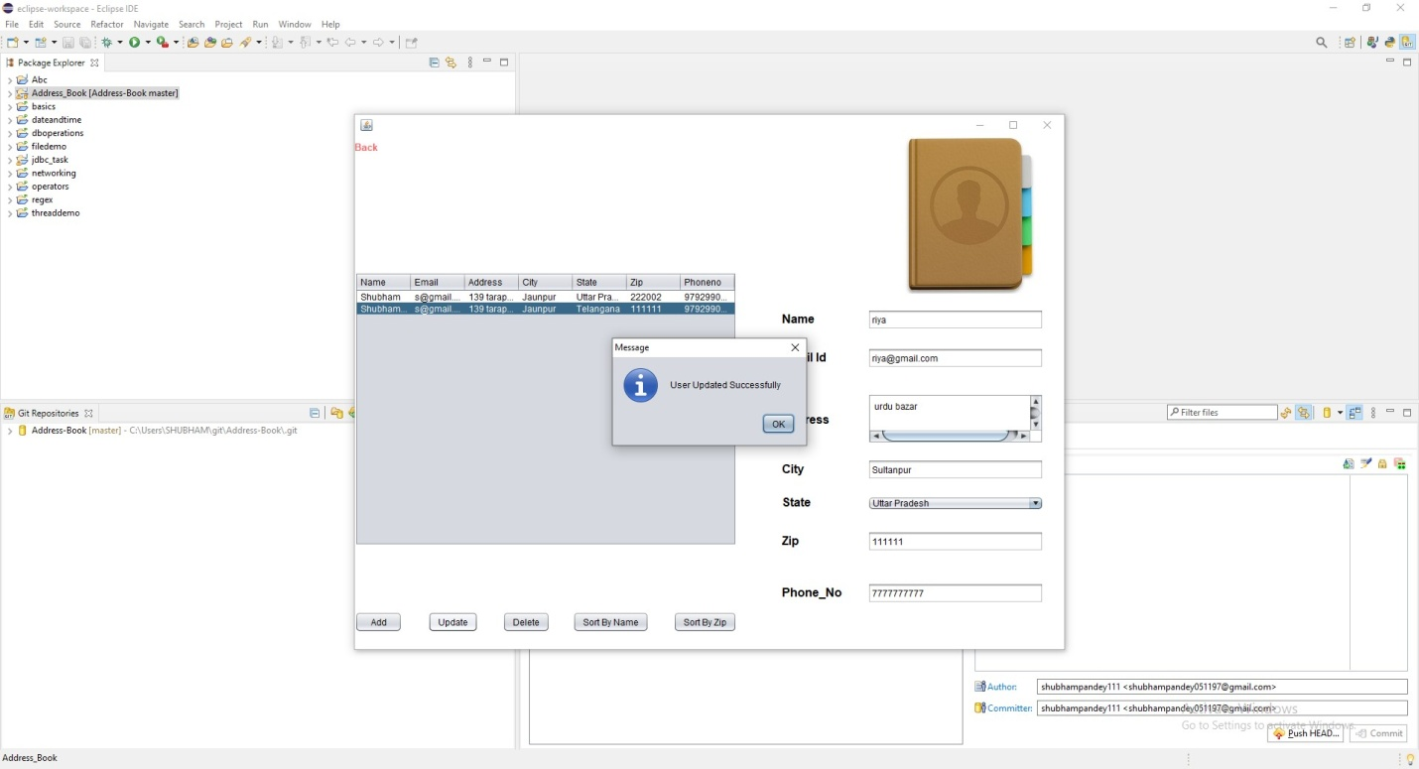

(4)Sort by name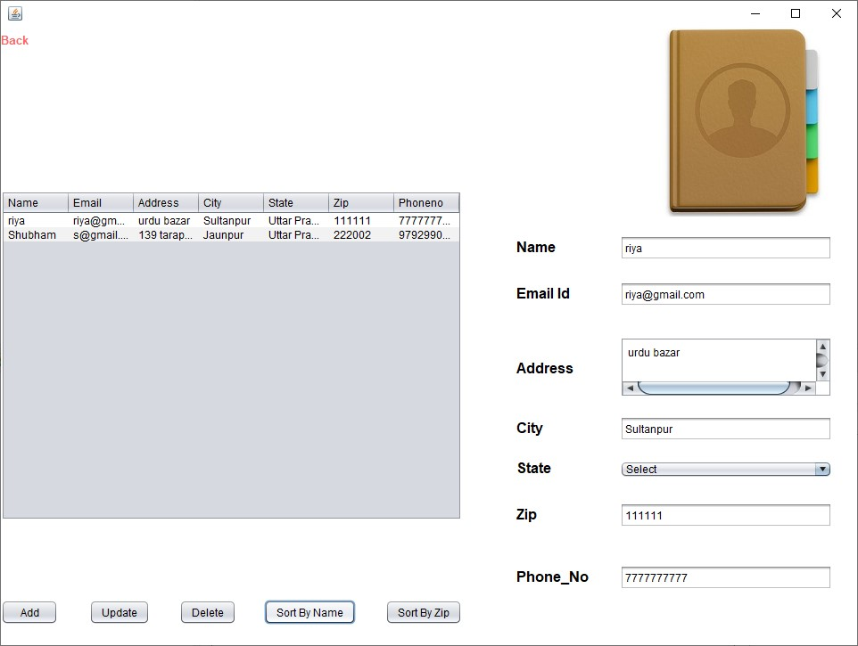

(5)Sort by zip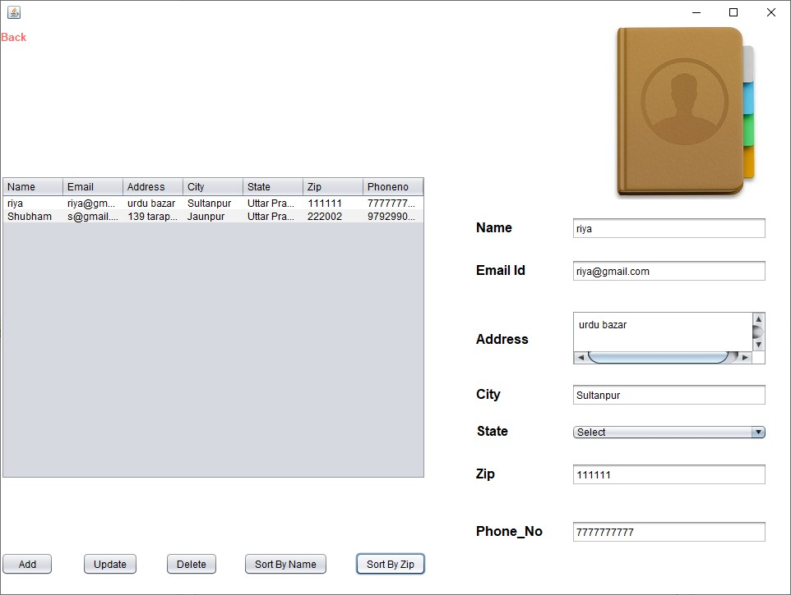

Database

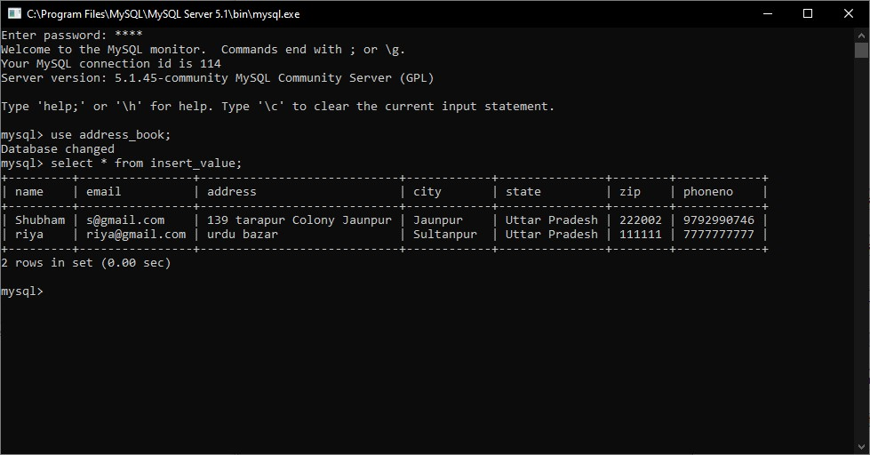

Technologies used were:

(1)Eclipse IDE

(2)java JDK 1.8 SE

(3)Mysql Server 5.1

(4) JDBC (java Database Connectivity)

*Thankyou.....!!!*